**Radix Sort**

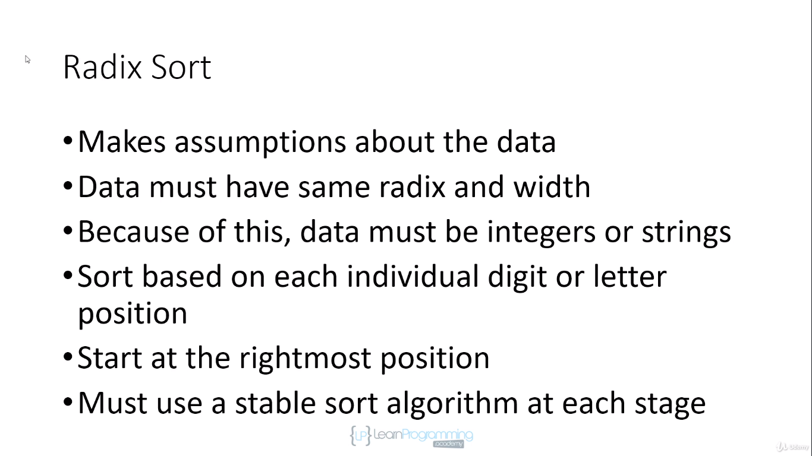

Radix means unique digits and values in digits, decimal have valid range from 0-9 digits so radix is 10

For alphabet its 26 from a-z

For binary its 2 only 0 and 1

Width means no of digits and letters for ex. 1245 have 4 width

For “hello” string width is 5, Number 10 has 2 width.

**Must use a stable sort algorithm at each stage**

**We have different array now all decimal no with width 4**

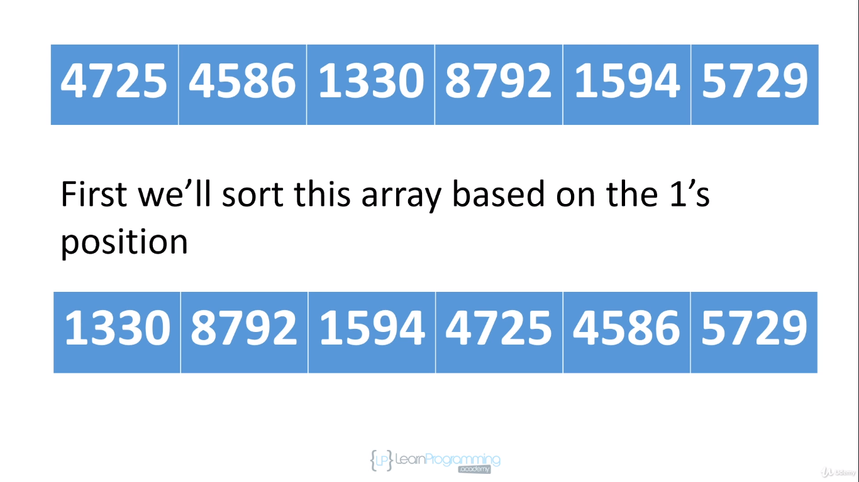

1’s position has least weight.

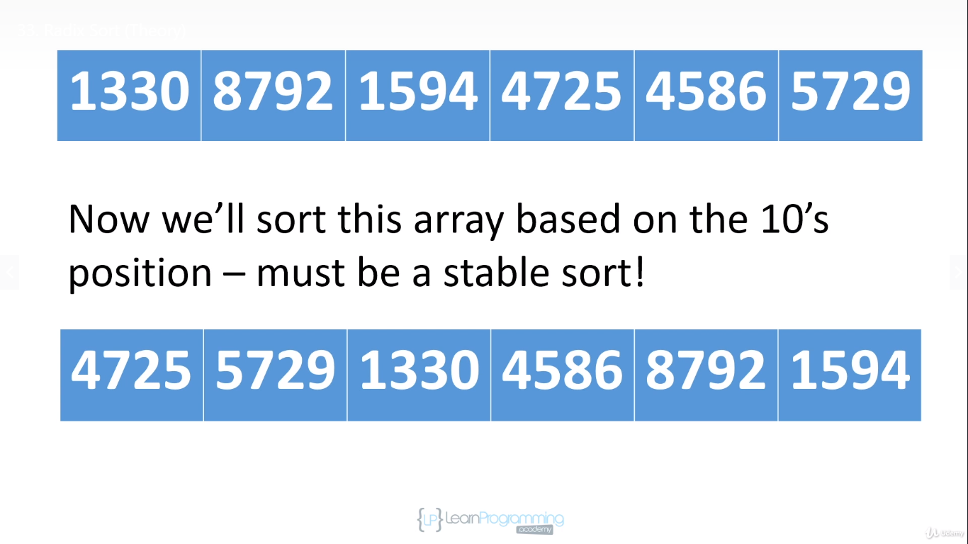

Now we sort on base of 2nd least significant digit 10’s position since we are using stable sort so we can see 4725 comes before 5729 in both the arrays thus position of 4725 will always be before 5729 as per stable sort.

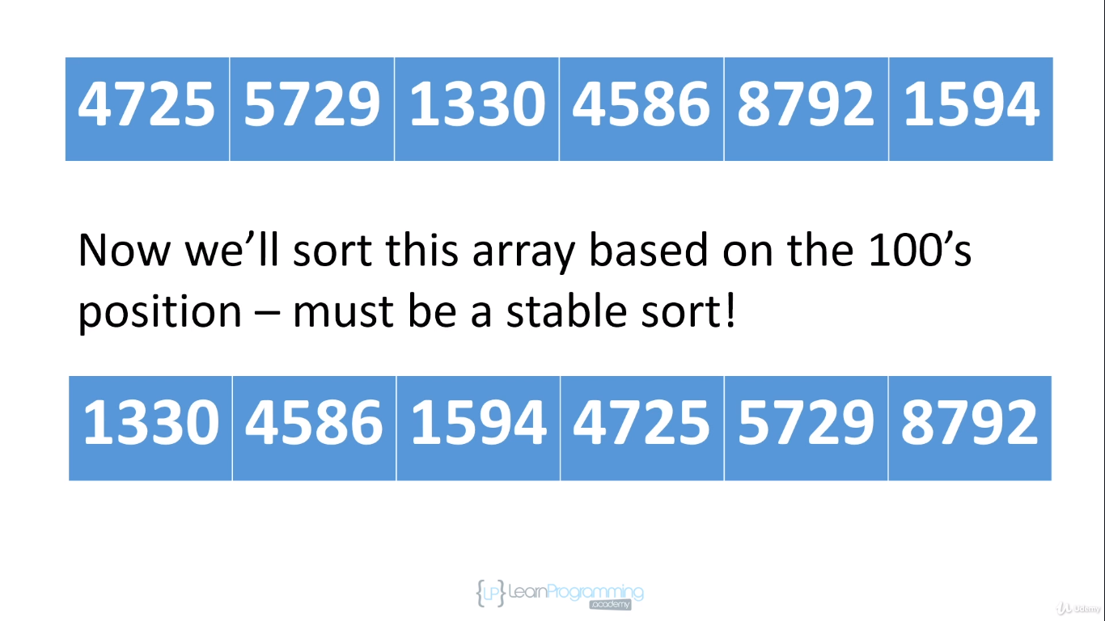

Now we sort on basis of 100’s position and once again we have to use stable sort algorithm as we can see three values with 7 at 100’s position so 4725 comes before 5729.

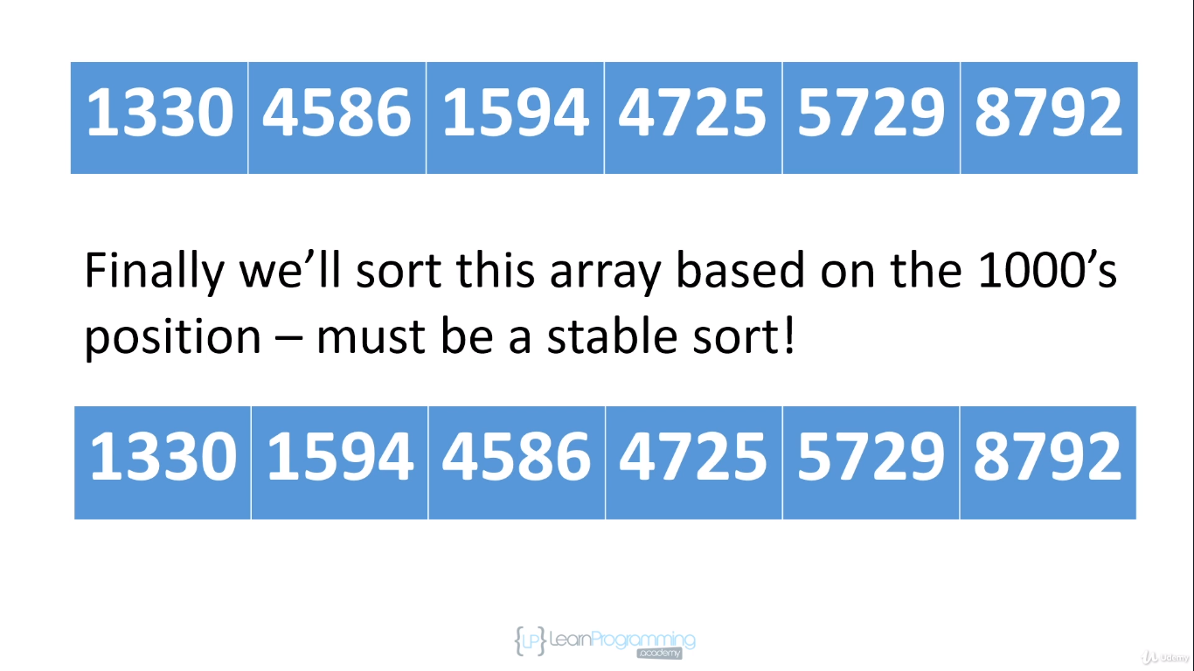

Now we sort on 1000’s position using stable sort algorithm we can see still 4586 comes before 4725.

We have sorted our array.

If it wasn’t stable this radix sort won’t work, so on every phase its stable sort.

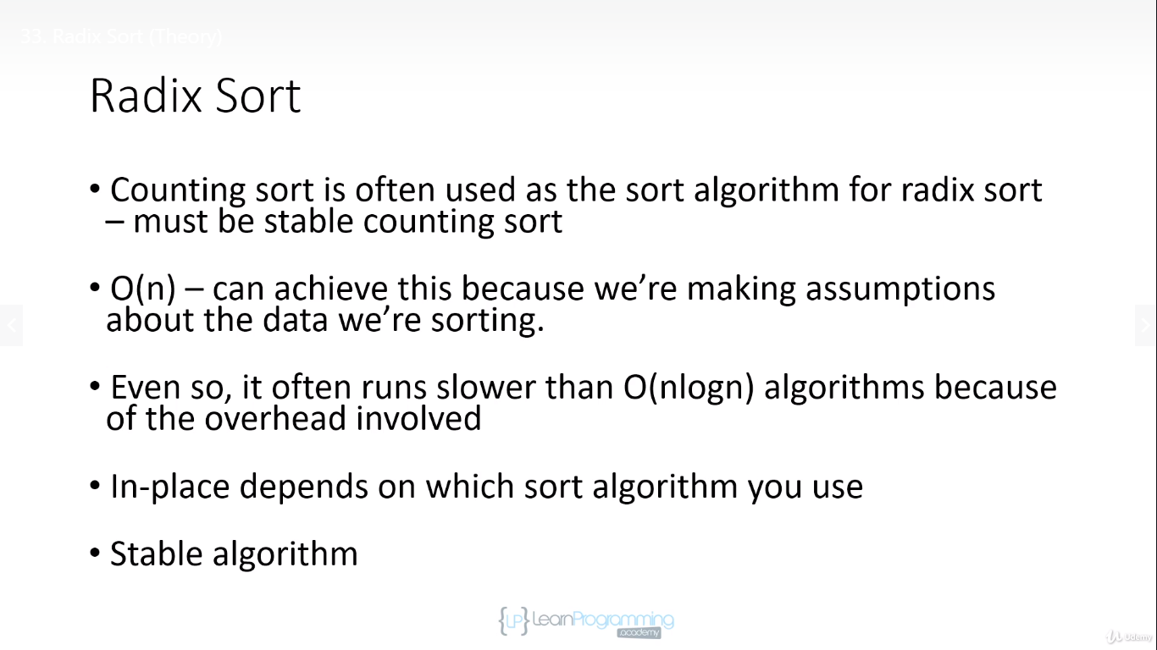

Its run slower than O(nlogn) as we have to isolate letters and digits at each position.

